DCA Note:
This document is a list of various Medici.tv performances that are Christmas themed or related in some way.
Please feel free to use any part of this doc, and edit it in any way you like, to create social media posts.
For example, you could pick 3-4 of your favourites from this list, and create a social media post about each - use the images and copy provided, or feel free to tweak it!
You could also tidy up this document and post the whole list for your customers. We recommend switching the links to the specific links for your library’s Medici login, which will make it easier for your customers to find the right video. To do this:

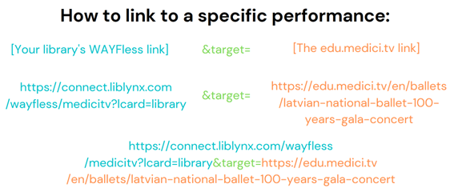

The Sleeping Beauty by Marius Petipa, music by Tchaikovsky
Marianela Núñez (Princess Aurora), Christopher Saunders (King Florestan XXIV), Elizabeth McGorian (The Queen) — The Royal Ballet

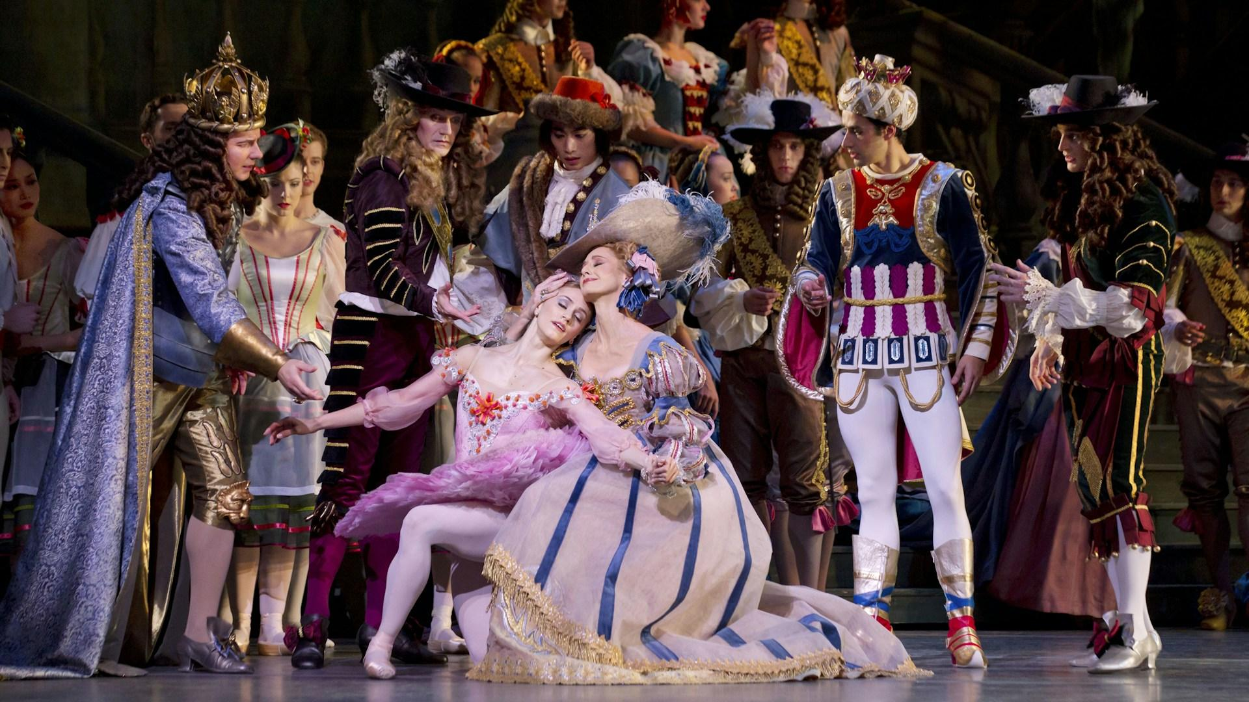
The "ever-perfect Marianela Nuñez and Vadim Muntagirov" (The Guardian) headline this immaculate Royal Ballet production of Tchaikovsky's The Sleeping Beauty, in the classic choreography by Marius Petipa!

The first collaboration between Tchaikovsky and Petipa, the 1890 ballet was an instant success in Russia but didn't become a widespread repertoire staple until after Tchaikovsky's death. For the last century, it has retained a place of honor in the rotation of ballet companies worldwide as one of audiences' most beloved classical ballets. The work's popularity is easy to understand: it contains some of the most beautiful, sweepingly romantic music ever written by Tchaikovsky; features a sublime and elegant choreography by one of the all-time masters; and recounts in dance one of the world's favorite fairy tales—a tale further immortalized in the Disney film, which also makes excellent use of Tchaikovsky's timeless score.

The Nutcracker and the Mouse King by Christian Spuck, music by Tchaikovsky
William Moore (The Nutcracker), Dominik Slavkovsky (Herr Drosselmeyer), Cohen Aitchison-Dugas (Mouse King), Mélissa Ligurgo (Mouse Queen) — Ballett Zürich
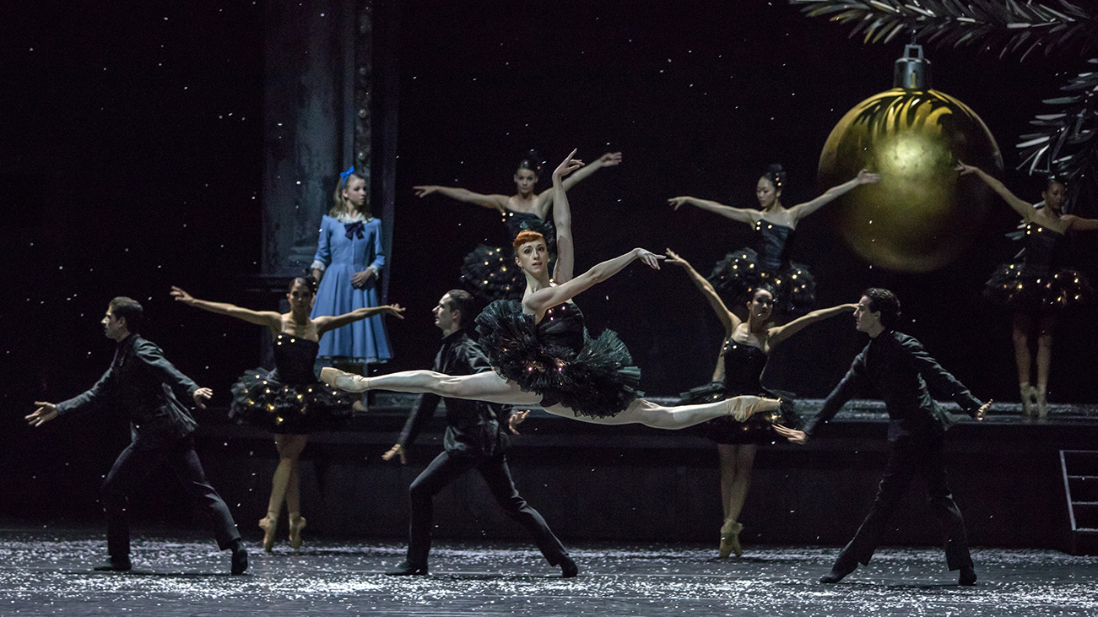
The Nutcracker, spectacular holiday ballet par excellence, like you've never seen it before—we promise—in a revisited version by visionary choreographer Christian Spuck. His mise en scène, poetic and precise, plunges more deeply than most versions into the source text by macabre master E.T.A. Hoffmann, creating a sort of chiaroscuro atmosphere that is both romantic and fantastic, bordering the sublime and the absurd.

Alondra de la Parra conducts Advent Concert from Dresden 2019 – With Regula Mühlemann, Julia Muzychenko and Julian Prégardien
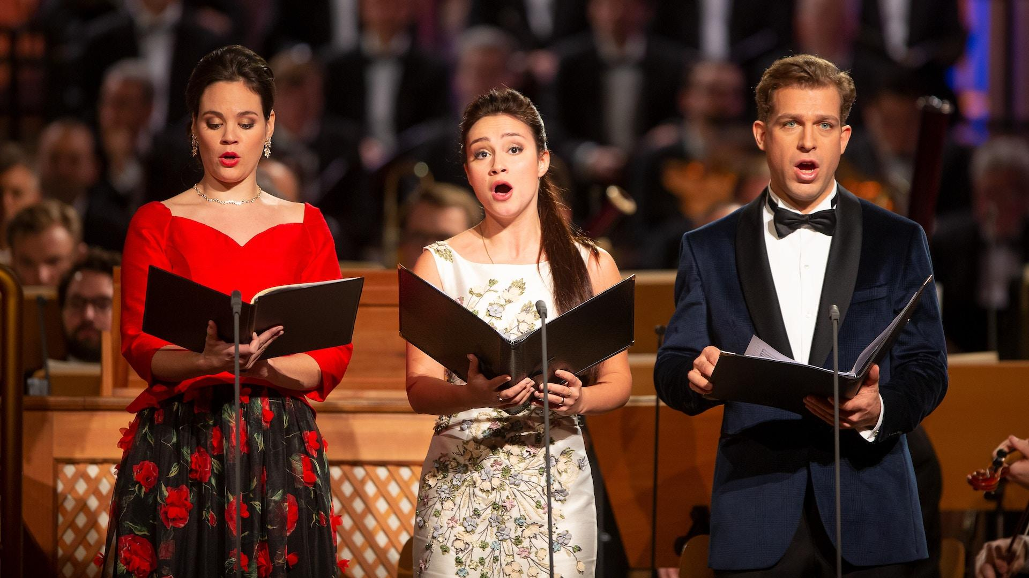
Bach's timeless, irresistible Christmas Oratorio returns to Leipzig—and to St. Thomas's Church, where several of its six gorgeous cantatas were heard for the very first time in 1734-35! Adding to the historical import of this unmissable event are the Gewandhausorchester, one of the world's oldest and most venerated orchestras founded in 1781, and the Thomanerchor (St. Thomas Choir of Leipzig), a legendary ensemble formed over eight hundred years ago in 1212 and directed by Bach himself between 1723 and 1750.
The eighteenth person to hold the post of Thomaskantor since Bach, Andreas Reize leads the impeccable orchestra and choir—joined by soloists Christina Landshamer, Benedikt Kristjánsson, and Konstantin Krimmel—in a festive and delightful performance of one of those cherished works from which the holiday spirit flows unfettered and ebullient.

Bach's Christmas Oratorio
One of the true treasures of the sacred choral repertoire.
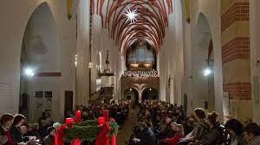
It was in 1734 in Leipzig’s St. Thomas Church where the Oratorio—made up of six cantatas composed for the major feast days of the Lutheran Christmas calendar—was first performed, and it is in the same church that Gotthold Schwarz, the seventeenth Thomaskantor (St. Thomas Church music director) since Bach’s own tenure, brings the masterpiece once more to life with his elite boy’s choir.

Gloria in Excelsis Deo: A Christmas Concert by Thomas Clamor and the Sächsische Bläserphilharmonie – With Ruth Ziesak
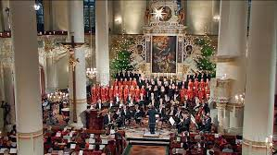
Christmas in the Erzgebirge region is one of Saxony’s most treasured traditions. Its unique celebrations include numerous customs focusing on music. In this film it is the setting for a concert of classical and seasonal works performed by an exquisite ensemble of wind instruments and Germany’s leading youth choir. In addition the prominent soprano Ruth Ziesak performs, in a program featuring seasonal Handel, Schuman, Wagner, Mendelssohn and Tchaikovsky among others.

The Nutcracker
As much a Christmas staple as mincepies and tinsel, The Nutracker has been timelessly enchanting audiences since 1892. Binge-watch this sumptuous ballet on Medici, with five very different premium performances from some of the world’s leading companies.

You would be hard-pressed to find a more dazzling production than this pristine 2018 recording from the Royal Ballet at Covent Garden.
If you like your nutcracker with a twist, try this performance from the Dutch National Ballet, which is set in the early 19th century during the feat of Saint Nicholas. A magical moment when Clara’s living room transforms into a snowy forest and sends dancers skating down frozen Dutch canals!
Or try the Nutcracker Sweeties, from The Birmingham Royal Ballet with music by Billy Strayhorn and Duke Ellington a 35 minute big-band take on the ballet as you have never seen or heard it before! It portrays Broadway and American in the 1940s: full of humour, irony, swing and blues. Dressed in an array of glamorous Jasper Conran costumes, the cast includes drum majorettes, sailors, pom-pom girls, GIs and Candy Kane. Fl;ashing neon sets and jazz-style choregography make this an imaginative, funny and visually irresistible short.
For fans of the original tale, The Nutcracker and the Mouse King (2018) by visionary choreographer Christian Spuck plunges more deeply than most versions into the 1816 text by master of the macabre, E.T.A. Hoffman. Both romantic and fantastic, bordering on the sublime and absurd, the corps de ballet of Ballett Zurich dance to an adapted score.
The US’s most revived staging of The Nutcracker originated from the New York City Ballet’s legendary director and choreographer George Balanchine (1954), incorporating more child dancers than ever before. In December 2011, film maker Alan Skog and the New York City Ballet produced a truly compelling performance of Balanchine’s classic choreography, earning an Emmy nomination in the process. (1h 39 min)

